Waabanong Weekly Update
Delivered May 27, 2026
Week of May 18 to 22, 2026
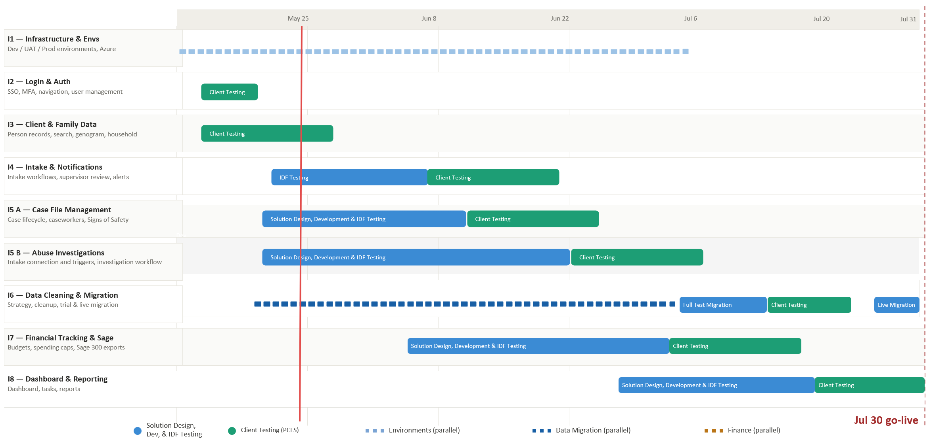

Iteration | Status | Current phase | Notes
I1 - System Infrastructure & Environments | In progress | Setting up Testing | Azure Testing environment data migration in progress
I2 - Login & Authorization | In progress | PCFS Testing
I3 - Client, Member & Family Data | In progress | PCFS Testing | Enhancements and fixes this week: person profile updates, improved person search (multi-word + typo tolerance), and profile-type conversion/synchronization fixes.
I4 - Intake Management & Automated Notifications | In progress | IDF Testing | Multiple bug fixes validated through internal testing.
I5 A - Case File Management & Signs of Safety | In progress | Solution design | Solution design specifications for Case Overview, Case Notes, Placements & SOS are in progress.
I5 B – Abuse Investigations | In Progress | Solution design | PCFS workflows integrated. Version two wireframes in progress
I6 - Data Migration | In progress | Planning | Working with Campfire to determine how to access data and maintain privacy/security
I7 - Financial Tracking & Exports for Sage | In progress | Solution design | Advanced wireframes for PO and credit-card reconciliation in progress; next finance working session pending
I8 - My Dashboard & Reporting | Not started

Project Management & General
Weekly Progress
- Continued coordination with PCFS and internal alignment on upcoming priorities (person profile + intake stability, then case wireframes/design).
- Prepared a plain-language MVP summary for client review covering Login, Person creation, Genogram, and Address Book expectations.

I1 - System Infrastructure & Environments
Features
- Set up Development, Testing, and Production environments
Weekly Progress
- Azure testing environment deployed for UAT.
- No client-facing changes this week; internal validation continues as the environment is stabilized.

I2 - Login & Authorization
Features
- Microsoft 365–based authentication
- User login
Weekly Progress
- User testing launched Wed May 20th.

I3 - Client, Member & Family Data
Features
- Centralized person records (children, adults, limited profiles)
  - Duplicate prevention
- Family and household structures
  - Multi-generation relationships
- Reciprocal relationship logic
- Global search across people and families
Weekly Progress
- Implemented and validated multiple person-profile improvements: profile updates, profile-type conversion handling, and cross-tab synchronization so updates reflect consistently.
- Improved person search to better support multi-word queries and tolerate minor typos; refined related task/profile display behaviors.
- User testing launched Wed May 20th, and ends June 3rd

I4 - Intake Management & Automated Notifications
Features
- Structured intake workflows with mandatory fields
- Intake status tracking and lifecycle
- Supervisor review and approval processes
- Ability to resolve intake without opening a case
- Escalation from intake to case creation
- Printable intake records
- Automated notifications:
  - In-application alerts
  - Defined external channels (email/messaging)
Weekly Progress
- Significant intake refinements this week: eligibility logic improvements, intake log sorting/notes display, household snapshot display fixes, and multiple bug fixes (including manual entry saving and “Date & Time Received” stability).
- Permissions and roles refinements for intake routing and task assignments

I5 A - Case File Management & Signs of Safety
Features
- Case file creation and lifecycle management
- Assignment of caseworkers and supervisors
- Case reassignment with approval
- Signs of Safety–aligned workflows, including:
  - Placement
  - Structured assessments
  - Safety goals and planning
  - Ongoing review checkpoints
- Visibility into historical and related cases
- Case notes for visits, services, and interactions
- Communication tracking across intake and case contexts
  - Document management: Person, Intake & Case
Weekly Progress
- No new client workshop sessions this week; solution design work continues based on prior Service Delivery walkthroughs.
- Automated tasks triggered during case file has been defined and incorporated into the solution
- Wireframes and solution design are progressing; next review session to be scheduled as needed with PCFS.
I5 B – Abuse Investigations
Features
- Triggers and integration with Intake module
- Investigation workflow
- Investigation document management

Weekly Progress
- No additional external review this week; Abuse Investigations remains in solution design, incorporating PCFS workflows.

I6 - Data Cleaning and Migration
Features
- Develop a data migration strategy from FAMCare into Waabanong
- Support PCFS as they perform data cleanup
- Execute trial data migrations in a sandbox environment
- Perform live data migration
Weekly Progress
- Data migration planning continues with Campfire, focusing on secure access, privacy, and approach for trial migrations.

I7 - Financial Tracking & Exports for Sage
Features (Potential scope may include)
- Intake-level emergency supports
- Case-level budgets
- Spending caps and approvals
- Export files to import into Sage 300
Weekly Progress
- Finance work remains queued for the next working session; no new finance work this week.

I8 - My Dashboard & Reporting
Features (Potential scope may include)
- My Dashboard (simple, quick reference to key items)
- Tasks & alerts
- Reporting (if required and not covered in other iterations)
Weekly Progress
- Future iteration per schedule (no dashboard/reporting work this week).

